**VEHICLE NUMBER PLATE RECOGNITION**

**Android:-**

In theory, you can write Android apps in a regular text editor or command line, but the common approach is using an Integrated Development Environment. This tool integrates SDK tools which help to manage in user-friendly manner. Android studio is an official android development IDE. Java is the language listed as the official languages for the development of android. In this application Java is used.

**Tools and Tecnology used :-**

1. Android Studios
2. Java
3. sqlite

**Overview of project:-**

Vehicle number recognition application has all record of particular vehicle if registered. Also it makes it easier for a person to fetch info. of vehicle at any time of any vehice all the information is stored in database. Due to storage of data in database there will be no loss of data from database. All the data like vehicle details and login details would be stored in database. Android can provide in making the application user-friendly and one which can be used by a large majority of people.

**SCREENSHOTS OF PROJECT :-**



**Home page which display 2 buttons :-**

1. LOGIN credentials
2. Registration of vehicle

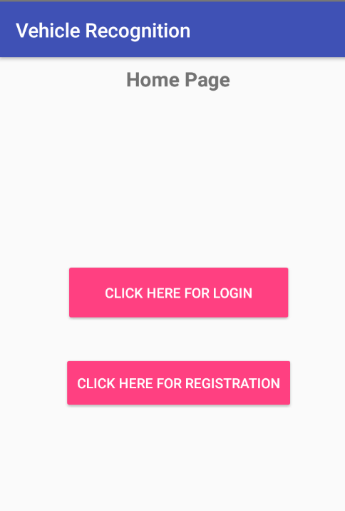 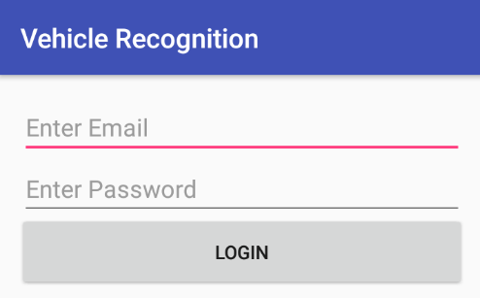

**Vehicle Recognition tab**(for registering vehicle) :-

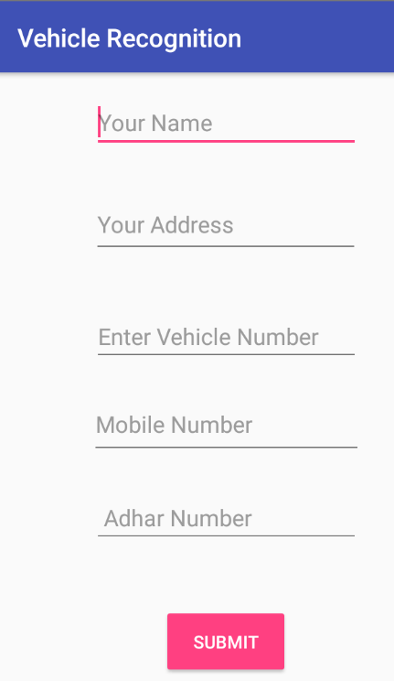

**Vehicle Registered :-**

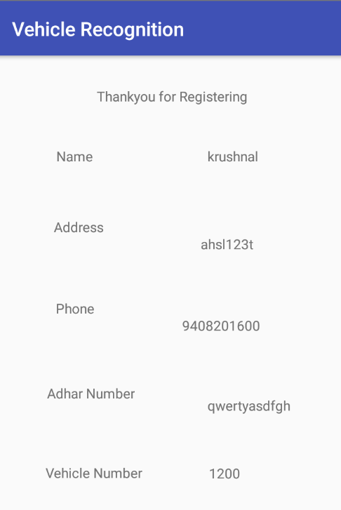

**OTP Verification:-**

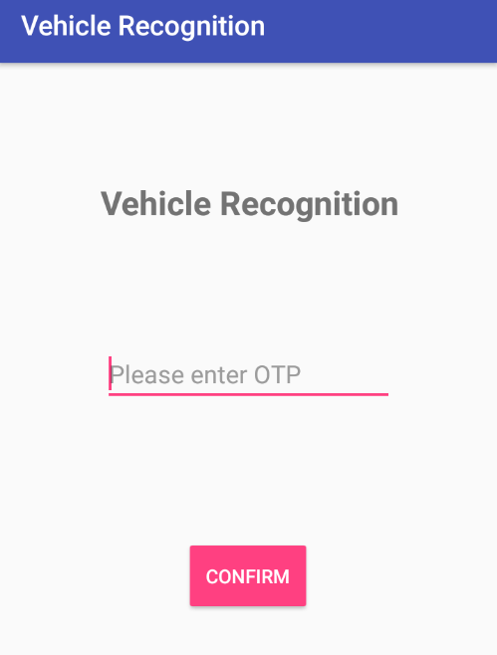

**Future Enhancements :-**

This application is platform it helps for security purpose it may help in security for getting details of vehicle with the help of this application. Also people can register their vehicle on this app and in future they can view details by logging in . It helps police department in fetching information from database where all the vehicle information is stored.

**References :-**

[https://www.javatpoint.com › android-tutorial](https://www.javatpoint.com/android-tutorial)

[https://www.tutorialspoint.com › android](https://www.tutorialspoint.com/android/index.htm)

https://stackoverflow.com › questions › tagged › android

<https://www.youtube.com>